**110550126 曾家祐**

**Homework 1: Face Detection**

**Part I. Implementation :**

* **Part 1: Load and prepare your dataset: dataset.py -> loadImages()**

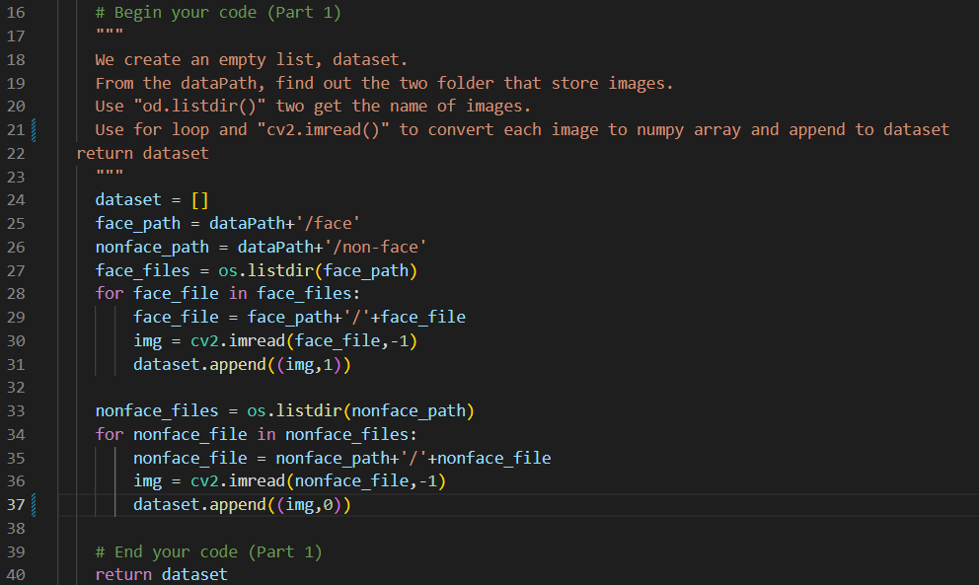

* **Part 2: Implement Adaboost algorithm: adaboost.py-> selectbest()**

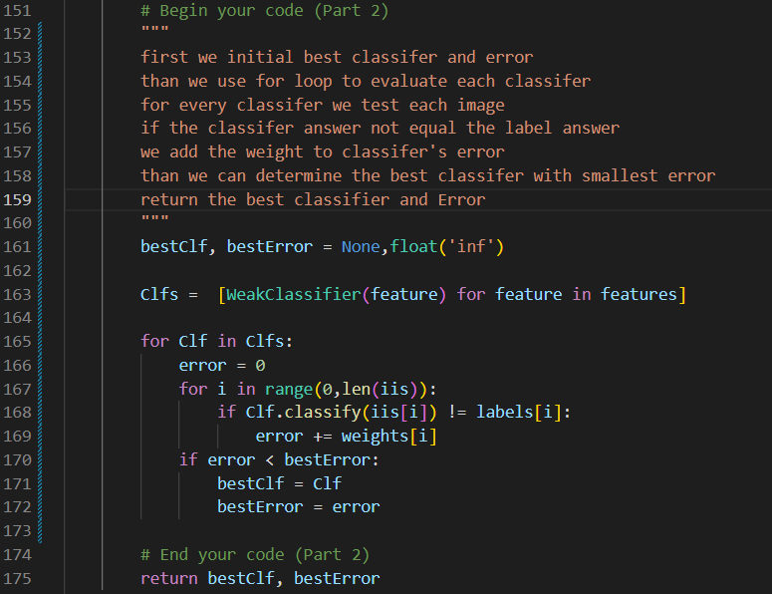

* **Part 4: Detect face: Detection.py-> detect()**

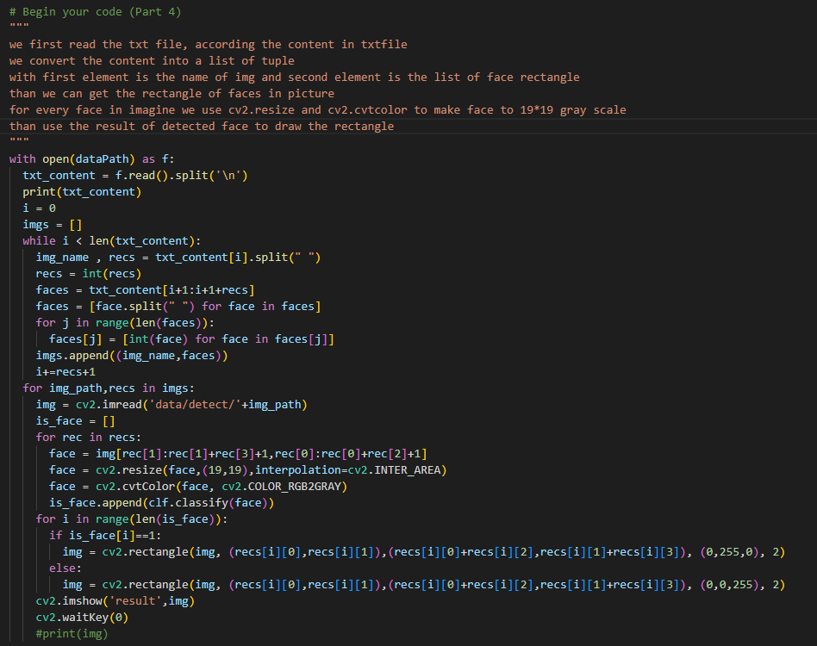

**Part II. Results & Analysis :**

* **Part 3: Additional experiments**

**Method 1 with threshold = 0, polarity = 1**

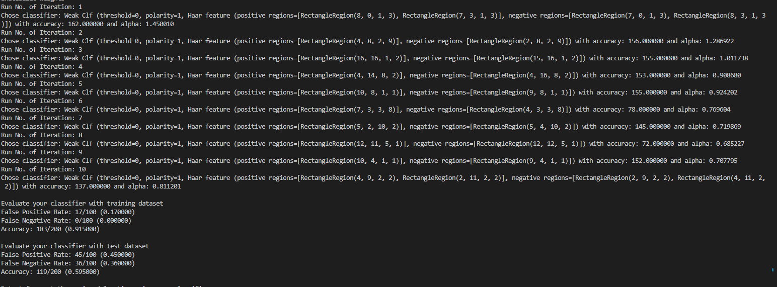

**Training model with T = 10**

**The table below is the result of our training model with t from 1~10,20,30,40,50. We can see that when t increase train data accuracy increasing , but t increase and have peak value at t = 10**

|  |  |  |
| --- | --- | --- |
| **200張** | **Train data accuracy** | **Test data accuracy** |
| **Method 1 t=1** | **81.0%** | **48.0%** |
| **Method 1 t=2** | **81.0%** | **48.0%** |
| **Method 1 t=3** | **88.0%** | **53.0%** |
| **Method 1 t=4** | **86.0%** | **47.5%** |
| **Method 1 t=5** | **88.5%** | **54.0%** |
| **Method 1 t=6** | **89.0%** | **51.0%** |
| **Method 1 t=7** | **90.0%** | **54.5%** |
| **Method 1 t=8** | **91.0%** | **55.0%** |
| **Method 1 t=9** | **90.0%** | **57.5%** |
| **Method 1 t=10** | **91.5%** | **59.5%** |
| **Method 1 t=20** | **97.0%** | **57.5%** |
| **Method 1 t=30** | **100.0%** | **54.0%** |
| **Method 1 t=40** | **99.5%** | **54.5%** |
| **Method 1 t=50** | **100.0%** | **54.0%** |

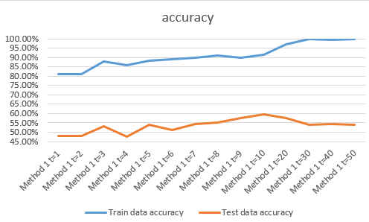**However when testing using image, the result with t = 2 is more higher than t = 10.**

* **Part 5: Test classifier on your own images**
* 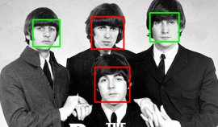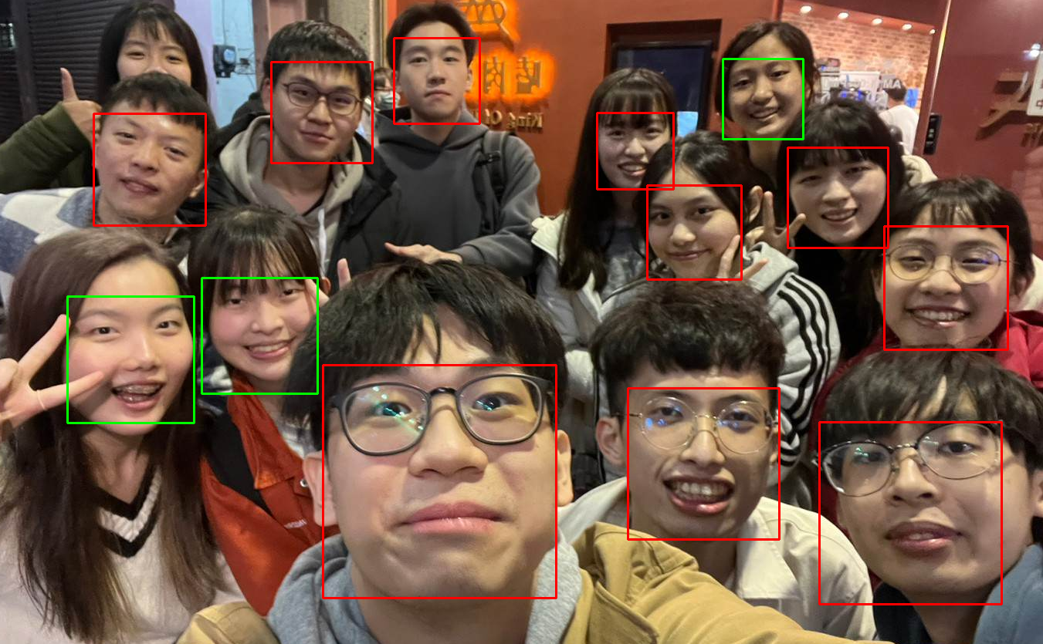

**⬆**Face detection “the-beatles.jpg” Face detection “my_pic.jpg” **⬆**

⬇Face detection “p110912sh-0083.jpg”

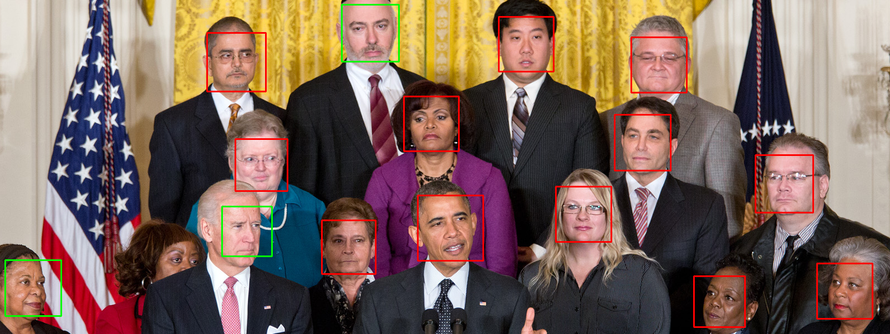

**With value t = 10**

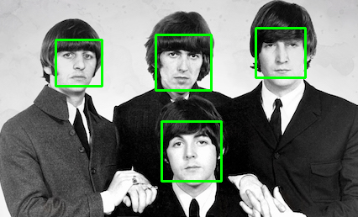 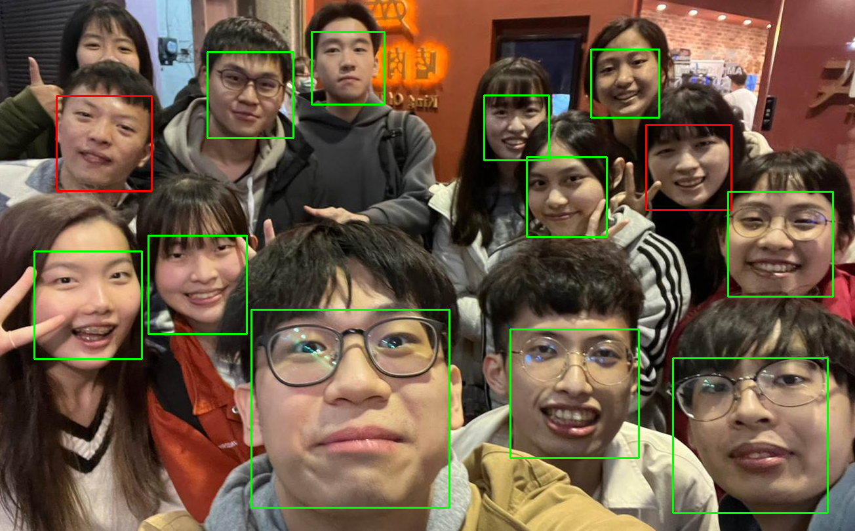

**⬆**Face detection “the-beatles.jpg” Face detection “my_pic.jpg” **⬆**

⬇Face detection “p110912sh-0083.jpg”

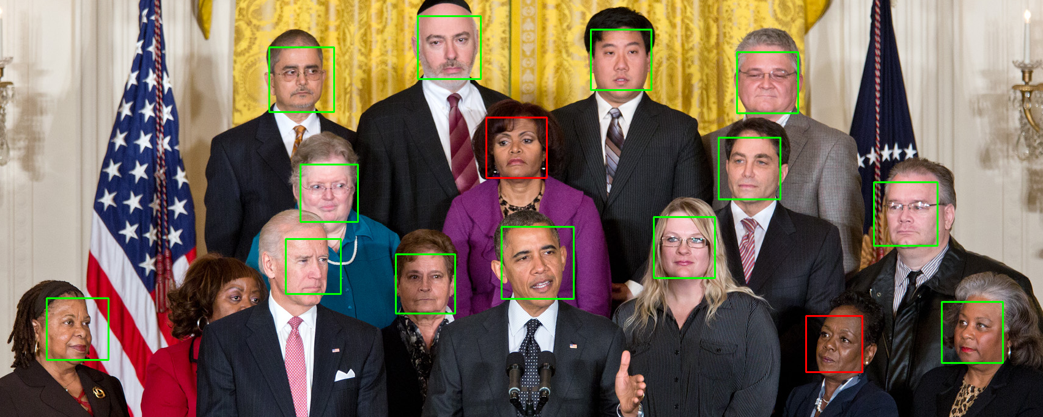

**With value t = 2**

* **Part III. Answer the questions**

1. Please describe a problem you encountered and how you solved it.

The problem I encountered is the datatype of each variable and the whole process of the algorithm.

The scale of the program is much greater than I write before. So I spend a lot of time on reading the code, and take the note about the input, result of each function. Further more I also search the articles Adaboost, Viola-Jones’ algorithm to understand the each part of these algorithm and know the whole process of the code.

2. What are the limitations of the Viola-Jones’ algorithm?

The limitation of Viola-Jones algorithm, is restricted to binary classification tasks, and since Viola-Jones’ algorithm is based on weakclassifier the features grow rapidly when the size of image grow. This make the training time grow rapidly to. So the viola-Jones’ algorithm is limited by the size of image.

3. Based on Viola-Jones’ algorithm, how to improve the accuracy except changing the training dataset and parameter T?

We can increase the size of input image (ex: 19*19 ->25*25). When the size of image increase, the features of image increase rapidly and avoid the distortion of image, since our images are much bigger than 19*19 image in training dataset. With more features, Viola-Jones’ algorithm can get higher accuracy.

4. Other than Viola-Jones’ algorithm, please propose another possible face detection method (no matter how good or bad, please come up with an idea). Please discuss the pros and cons of the idea you proposed, compared to the Adaboost algorithm

I think the face detection should not influenced by the color of people

The Harra features used the brightness and darkness of image as features to recognize the face or not, however black people face image may not have such different part between brightness and darkness. Rather than only the color, my algorithm should also consider the relative position of facial and formatting the color of images, that can make the different between people not that much.

Compare to the Adaboost algorithm, my algorithm pros is can eliminate the weakness of detect black people’s face, but the cons is may detected the image that is not face but have the same relative position part as human face.

* **Part 6: Implement another classifier (Bonus)**

**Method 2: with decided threshold and polarity by function “classifier.py -> train_weak()” to generate weakclassifier rather than default threshold = 0, polarity = 1**

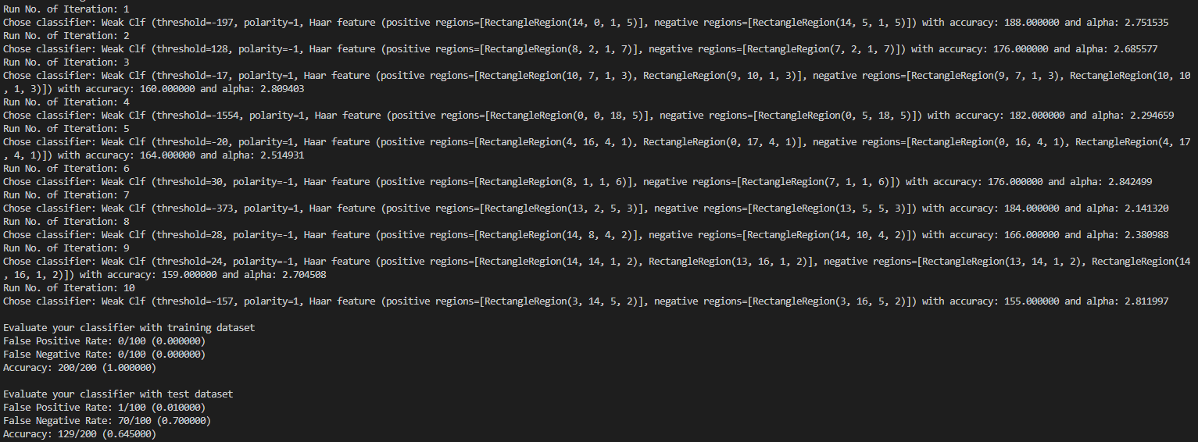

**Training model with T = 10**

* **Code to train threshold and polarity**

**Before: **

**After: **

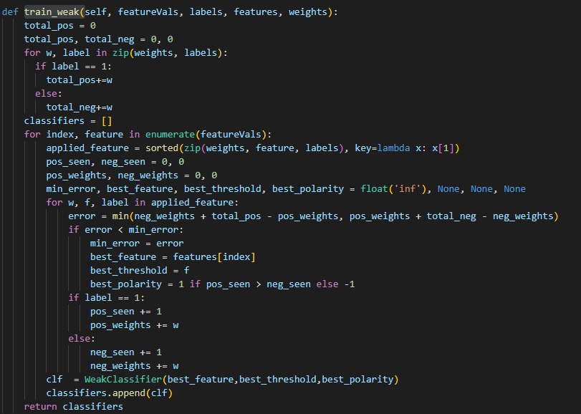

**Training model with T = 10**

**The table below is the result of our training model with t from 1~10,20,30,40,50. We can see that when t increase train data accuracy increasing , but t increase and have peak value at t = 8**

|  |  |  |
| --- | --- | --- |
| **200張** | **Train data accuracy** | **Test data accuracy** |
| **Method 2 t=1** | **94.0%** | **68.0%** |
| **Method 2 t=2** | **94.0%** | **68.0%** |
| **Method 2 t=3** | **100.0%** | **62.5%** |
| **Method 2 t=4** | **100.0%** | **62.5%** |
| **Method 2 t=5** | **100.0%** | **71.0%** |
| **Method 2 t=6** | **100.0%** | **63.5%** |
| **Method 2 t=7** | **100.0%** | **72.5%** |
| **Method 2 t=8** | **100.0%** | **74.0%** |
| **Method 2 t=9** | **100.0%** | **73.0%** |
| **Method 2 t=10** | **100.0%** | **64.5%** |
| **Method 2 t=20** | **100.0%** | **65.5%** |
| **Method 2 t=30** | **100.0%** | **64.5%** |

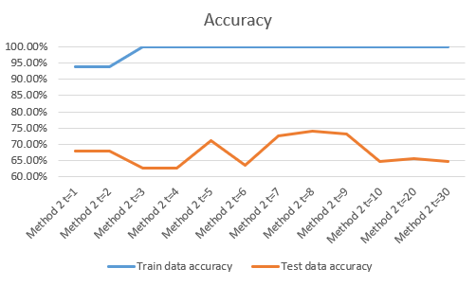

**We can see the result of changing threshold and polarity is much better than before we only set threshold = 0, polarity = 0.**

**When testing using image, the best result is t = 8 same as the evaluate before we did.**

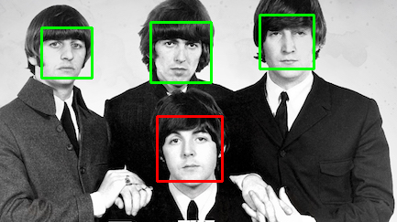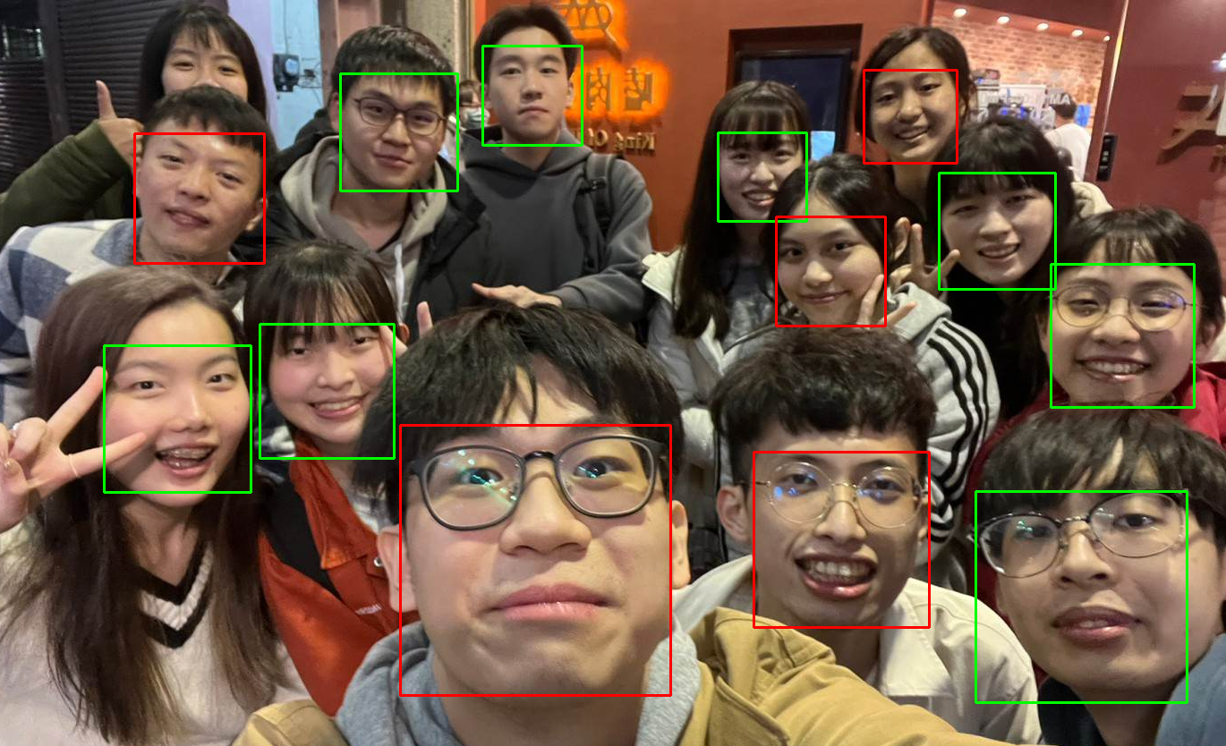

**⬆**Face detection “the-beatles.jpg” Face detection “my_pic.jpg” **⬆**

⬇Face detection “p110912sh-0083.jpg”

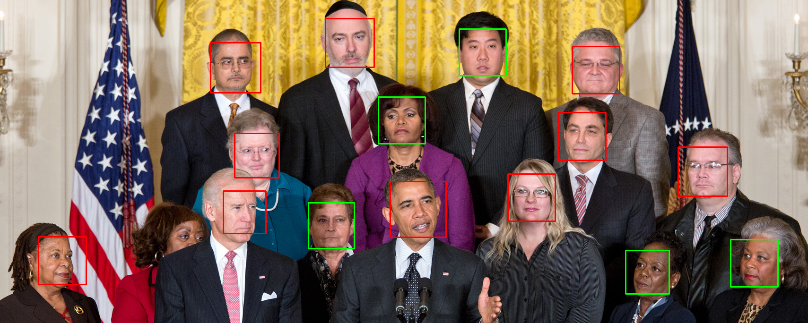

**With value t = 10**